**Computer Logic lab**

1. Using the partial circuit, which can be found in the labs folder on blackboard, complete the ripple carry adder, which is capable of adding 2 4-bit numbers. Test your circuit by adding the following 4 bit numbers:
   1. 0011

+ 0111

=A

* 1. 0101

+ 0001

=6

* 1. 0011

+ 0010

=5

* 1. 1000

+ 0011

=9

* 1. 1010

+ 0011

=D

* 1. 1101

+ 1000

=5

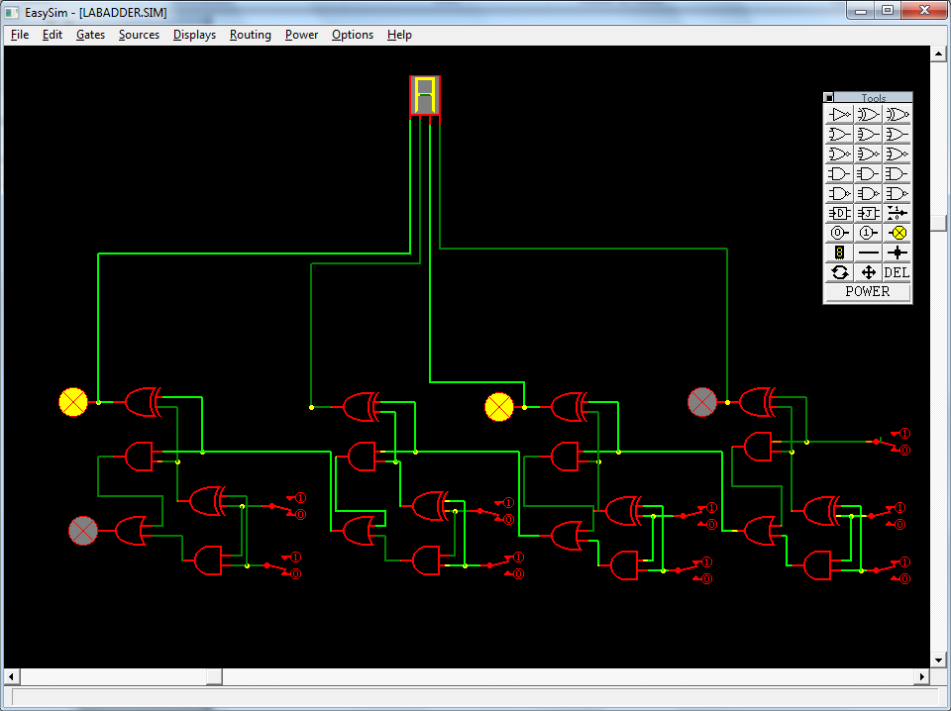

1. Using a black box design, draw the 4-bit ripple carry adder below:

